Lecture-01, Differential Calculus and coordinate Geometry(Math-1), Sunday, January 30, 2022

Course Teacher: Prof. Dr. Kh. Abdul Maleque

Indices:

Logarithm:

Trigonometric function: Ratio between two sides of right-angled triangle is called trigonometric or circular function which is represented by sine, cosine or tangent.

Cartesian/rectangular form (

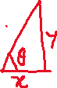

Polar form



Write the polar form of the point

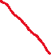

#Convert to rectangular coordinates

Cartesian form

#

Interval:

Marks distribution:

Quizes 40% (Best of two will be counted from three quizzes)

Written (MCQ 20 marks+Viva 20 marks) 40%

Attendance +Performance 10%

Assignment 10%

Total grand= 40% of Midterm +60% of Final term

Lecture-02, Differential Calculus and coordinate Geometry(Math-1), Tuesday 01/02/2022

Quadrant

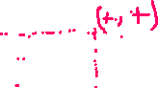

Function

Constant: Constant is a symbol which takes unchanged value

Constant is represented by

Variable: Variable is a symbol which takes changeable value

and is represented by

Two types of variable: (i) Dependent variable (ii) Independent variable

Let variable depends on the variable then we may write

Domain: exists for the value(s) of , set of the value of is called domain, domain is represented by

exists for

(i) Denominator not equal to zero

(ii) Inner of square root is not negative

(iii) Inner of logarithm is not negative and zero

Find the domain and the range of the following functions

Range: range

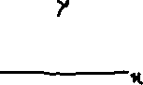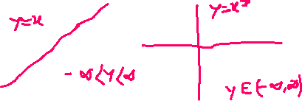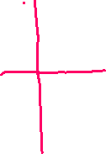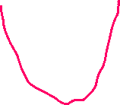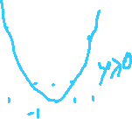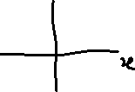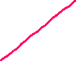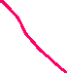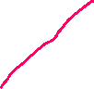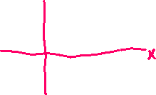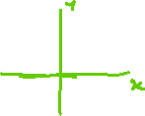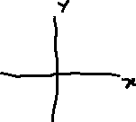

Lecture-03, Differential Calculus and coordinate Geometry(Math-1), Sunday 06/02/2022

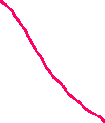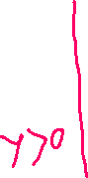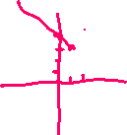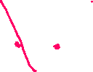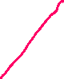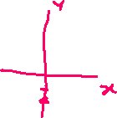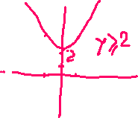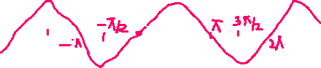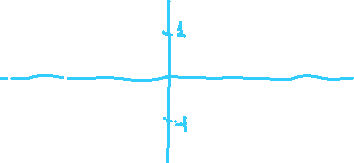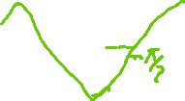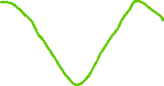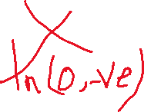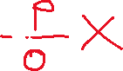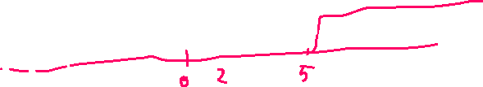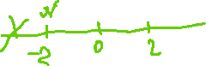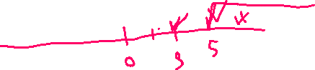

#

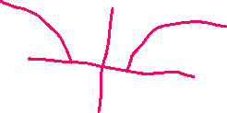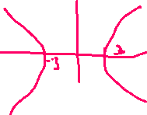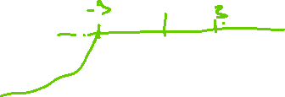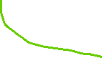

Limit:

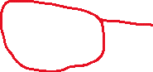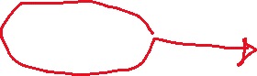

Exercises , ,

*L.Hospital rule:*

Lecture-04, Differential Calculus and coordinate Geometry(Math-1), Tuesday 08/02/2022

Ex11.

=

OR

Page-138

Continuity

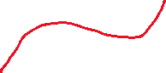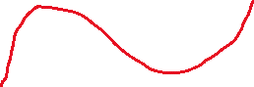

is continuous from A to B

is not continuous function from A to D

Def: is continuous function at if

is continuous function at if

Otherwise discontinuous function

is continuous or not at

does not exist. So f(x) is not continuous function at x=2.

at .

OR

OR

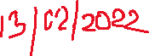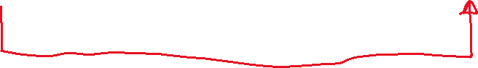

is continuous at x=2.

at .

is not continuous function at

Lecture-05(Makeup of Sunday), Differential Calculus and coordinate Geometry(Math-1), Thursday 10/02/2022

Differentiation:

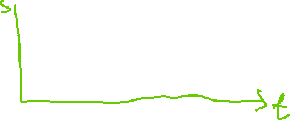

Change of time

Change of displacement

Rate of change is

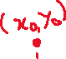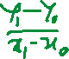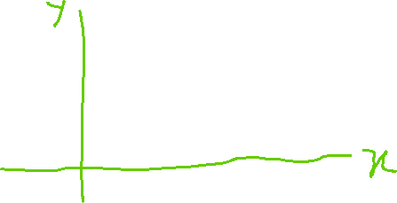

b

Is called First principle of differentiation

Find the differentiation of the following functions

By using 1st principle of differentiation, we have

Lecture-06, Differential Calculus and coordinate Geometry(Math-1), Sunday 13/02/2022

Differentiation of inverse trigonometric function:

Let

Putting

Putting

Differentiation of the product/division of two functions

Quiz-01 has been taken

Lecture-07, Differential Calculus and coordinate Geometry(Math-1), Sunday 15/02/2022

From Equation of circle:

Putting

From equation of Ellipse:

Putting

Hyperbolic function

Putting

mii

,

Chain rule:

Let

Find

Equation of straight line Slope( Gradient)

Equation of tangent and equation of normal

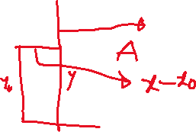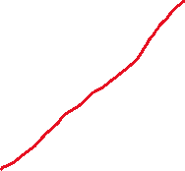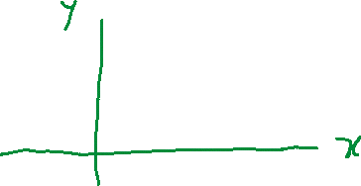

Line AB is called tangent of the curve at point P(



Let be the point on the line AB

is called equation of tangent.

Where

Let PR be the perpendicular line to AB

Slope of PR, is

Equation of normal at the point P is

Q. Find the equation of tangent and normal to the curve

at

Equation of tangent at (1, 1) be

Equation of normal

Equation of normal passes through the point (1,1)

Differentiation of implicit function:

Explicit function:

Implicit function: Easily cannot be found the value of y for the value x

Differentiating with respect to (w.r.t)

Find eq1.

Differentiating with respect to (w.r.t)

Q. Find the equation of tangent and normal to the curve

at

Equation of tangent

Equation of normal

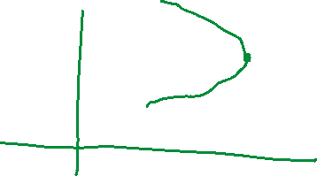

Lecture-08 (makeup of Tuesday), Differential Calculus and coordinate Geometry(Math-1), Thursday 17/02/2022

Parametric equation:

Q. Find

Q3. Find the equations of tangent and normal to the curve

If

Point

At

Equation of tangent at the point is

Equation of normal at (3,-1) is

Differentiation by logarithm

1. If given function is consisted the product/ division by more then two functions then we may use logarithm

2. If given function is consisted by function to the power function then we must use the logarithm

Ex.

Taking

Differentiating w.r.t.

Q2. Find

]

Q. Find

#

Quiz-02 will be held on Tuesday 22/02/2022